Republic of the Philippines
PALOMPON INSTITUTE OF TECHNOLOGY
Palompon, Leyte

COLLEGE OF TECHNOLOGY AND ENGINEERING
INFORMATION TECHNOLOGY DEPARTMENT
IT 118: Software Engineering
P14 – Deployment & Scaling Plan
Submitted as a Partial Requirement for this Subject by:

BSIT, 3rd Year

[Group Members]
Submitted to:

Subject Instructor

May 2026

1. System Overview

1.1 Project Description
The PIT Facility and Equipment Request System (PITFR) is a web-based reservation and scheduling platform developed for Palompon Institute of Technology. It digitizes and centralizes the process of requesting school venues and equipment for official academic and institutional events. Prior to the system's development, faculty, students, and organizations submitted requests manually—through paper forms or informal coordination—with no mechanism to detect scheduling conflicts, track approval status, or audit equipment usage.
PITFR enables requestors to submit structured reservation requests for venues (e.g., CHIC Conference Hall, PIT Multi-Purpose Gymnasium, Balay Alumni Function Hall, PIT Oval Ground, Basketball Court, Volleyball Court) and equipment (e.g., sound systems, microphones, canopies, industrial fans, Iwata cooler fans, tables, monoblock chairs). The system enforces a multi-level approval workflow—Custodian review followed by Admin final approval—and automatically detects time-slot conflicts to prevent double-booking. Additional features include email notifications via Mailtrap SMTP, a calendar view of reservations, PDF and Excel report generation, file attachment support for supporting documents, and a comprehensive audit log of all system actions.
The system is built on Laravel 12 with a MySQL relational database, styled using Tailwind CSS v3 and bundled with Vite. It follows a nine-table normalized schema: users, venues, equipment, facility_requests, facility_request_venues, facility_request_equipment, request_attachments, audit_logs, and notifications. It is deployed on a local XAMPP environment (C:\xampp\htdocs\pitfr, database: pitfr) during development and intended for on-premise server deployment within the PIT campus.

1.2 Target Users
1.2.1 Who will use the system?
PITFR serves five distinct user roles within the institution. Students and Faculty act as Requestors—they submit facility and equipment reservation requests, track their approval status, and receive email notifications at each workflow step. Custodian-Venue and Custodian-Equipment officers are the first-level approvers responsible for validating the availability of specific venues or equipment and recommending approval or denial. The Admin role holds final approval authority, manages all user accounts, oversees the master schedule, generates system-wide reports, and reviews the full audit log. This role-based segregation ensures that approval responsibilities are distributed appropriately across PIT's administrative structure.

1.2.2 Expected number of users
PITFR is designed to support the institutional user base of Palompon Institute of Technology. The requestor population includes all enrolled students and faculty members—potentially several hundred active users per semester. However, concurrent system usage is expected to remain low-to-moderate, with peak activity occurring at the start of each academic semester when events and activities are planned. Administrative users (custodians and admin) are estimated at 3 to 6 concurrent users. The system architecture is therefore optimized for moderate concurrent load with high transactional integrity rather than massive-scale throughput.

1.3 System Type
☑ Web Application
☐ Mobile Application ☐ Desktop Application ☐ Hybrid
PITFR is developed as a web application built on the Laravel 12 PHP framework, accessible through standard browsers (Google Chrome, Mozilla Firefox, Microsoft Edge) without requiring client-side software installation. The system follows a client-server MVC architecture: the Blade templating engine renders the user interface on the client side, while all business logic—conflict detection, approval workflow enforcement, audit logging, and notification dispatch—is executed server-side. The MySQL database serves as the centralized data store. This architecture enables simultaneous multi-role access, simplifies version management, and allows centralized data governance aligned with PIT's administrative requirements.

2. Deployment Architecture
PITFR follows a three-tier client-server architecture: a presentation tier (web browser), an application tier (Laravel/Apache), and a data tier (MySQL). During development, all tiers are co-located on a single Windows/XAMPP local machine. In the intended production deployment, the three tiers are hosted on a dedicated on-premise server within the PIT campus network, accessible to institutional users via the campus local area network (LAN) or intranet. This centralized on-premise model is selected for institutional data control, compliance with the Philippine Data Privacy Act (RA 10173), and cost-effectiveness appropriate to the institution's scale.

2.1 Architecture Diagram
The PITFR architecture is structured as follows: Client workstations and devices operated by students, faculty, custodians, and administrators send HTTP/HTTPS requests via the campus network to the Apache web server. Laravel's routing layer directs requests to the appropriate controllers, which enforce role-based access control (RBAC) and execute business logic—including time-slot conflict detection for venues and quantity-available checks for equipment. The application interacts with the MySQL database through Laravel's Eloquent ORM to read and write reservation records, approval decisions, audit entries, and notification payloads. For file operations, the system writes request attachments to a designated storage directory on the server. Outgoing email notifications are dispatched via the Mailtrap SMTP driver to the institution's configured mail service.

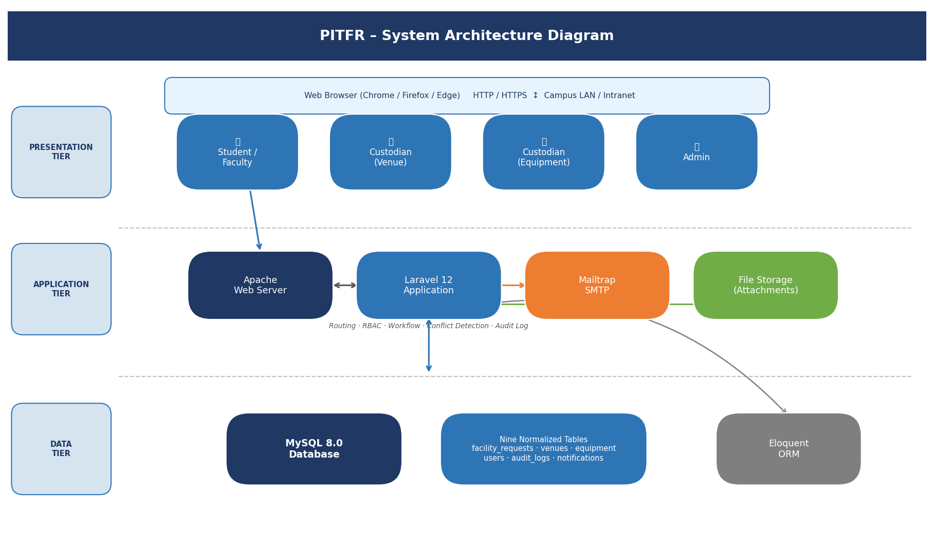
Figure 1. PITFR Three-Tier System Architecture Diagram

2.2 Component Description
Component | Description
Client Browser | The interface layer. Students, faculty, custodians, and administrators access PITFR through standard browsers. Blade-rendered HTML pages and Tailwind CSS provide responsive UI components without requiring client-side frameworks.
Apache / Laravel Routing | Handles incoming HTTP/HTTPS requests and routes them to the appropriate Laravel controller based on URI and HTTP method. Manages middleware for authentication and role-based authorization.
Laravel Application Layer | The core business logic tier. Implements the multi-level approval workflow (Custodian → Admin), time-slot conflict detection for venues, quantity-based availability checks for equipment, audit log writes, and SMTP email notification dispatch.
MySQL Database Server | The data persistence layer. Stores all structured records across nine normalized tables: users, venues, equipment, facility_requests, facility_request_venues, facility_request_equipment, request_attachments, audit_logs, and notifications.
Eloquent ORM | Laravel's object-relational mapper. Manages all database interactions including pivot table relationships (facility_request_venues, facility_request_equipment), soft deletes, and model event hooks for audit logging.
Mailtrap SMTP Driver | Handles outbound email notifications to requestors and approvers at each stage of the approval workflow. Configured via Laravel's mail driver settings in the .env file.
File Storage (Laravel Storage) | Manages uploaded supporting documents (request_attachments) using Laravel's local disk driver. Files are stored in the server's storage/app directory and served through signed URLs.
Vite + Tailwind CSS | Frontend build toolchain. Vite bundles CSS and JS assets during development; Tailwind CSS v3 provides the utility-first styling framework for all UI components.

3. Deployment Environment
PITFR follows a structured three-environment deployment lifecycle: Development, Testing/Staging, and Production. Each environment is isolated to ensure that active development does not disrupt live operations and that system changes are validated before release. The development and testing environments are maintained on developers' local Windows machines using XAMPP, while the intended production environment is a dedicated on-premise server within the PIT campus network.

3.1 Environment Setup
Environment | Purpose | Stack
Development | Active feature development, unit testing, and local debugging by team members. Each developer maintains an independent XAMPP instance at C:\xampp\htdocs\pitfr. | Windows 10/11, XAMPP (Apache + MySQL 8.0 + PHP 8.2), Laravel 12, Vite dev server, Mailtrap sandbox SMTP
Testing / Staging | System integration testing, user acceptance testing (UAT), and pre-release validation. Mirrors production configuration to detect environment-specific issues. | Same XAMPP stack as development; shared staging database seeded with representative test data; Mailtrap inbox for email verification
Production | The live operational system used by PIT students, faculty, custodians, and administrators for official facility and equipment reservations. | Dedicated on-premise server (Linux or Windows Server), Apache, MySQL 8.0, PHP 8.2, Laravel 12 production mode (.env APP_ENV=production)

3.2 Deployment Flow
The system transitions through environments following a controlled release process. Development occurs on individual team members' local XAMPP environments, with source code version-controlled in a shared Git repository hosted on GitHub. Once a feature or bug fix is complete, it is pushed to the repository and merged into the staging branch after peer code review.
In the Testing/Staging phase, the team conducts integration tests—verifying conflict detection logic, approval workflow transitions, and email notification dispatch. User acceptance testing (UAT) is performed with representative PIT staff. Upon approval from the subject instructor and system stakeholders, the staging branch is merged into the main production branch. Production deployment is performed manually by the lead developer via SFTP or SSH, followed by execution of Laravel migration scripts (php artisan migrate --force) to apply schema changes. A post-deployment smoke test verifies that login, reservation submission, approval workflow, email notifications, and report generation are all functioning correctly before the system is handed over.

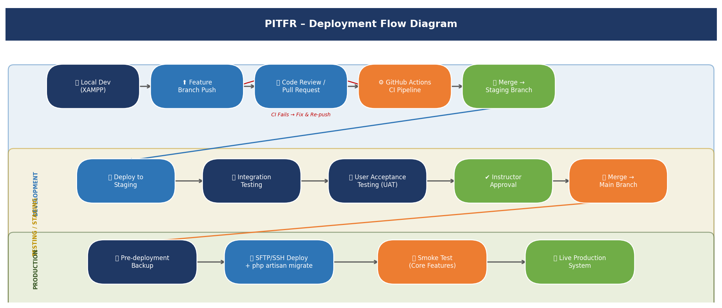
Figure 2. PITFR Deployment Flow – Dev → Staging → Production

4. Scaling Strategy
The scaling strategy for PITFR is designed around PIT's operational profile: an academic institution with a faculty and student user base numbering in the hundreds, served by a small administrative team of custodians and an admin officer. The primary scaling concern is not sustained high-volume traffic but rather handling peak reservation activity at the start of each academic semester, when the majority of event requests for venues and equipment are submitted. The scaling approach prioritizes vertical scaling of the on-premise server as the most pragmatic and cost-effective solution for the institution's operational context.

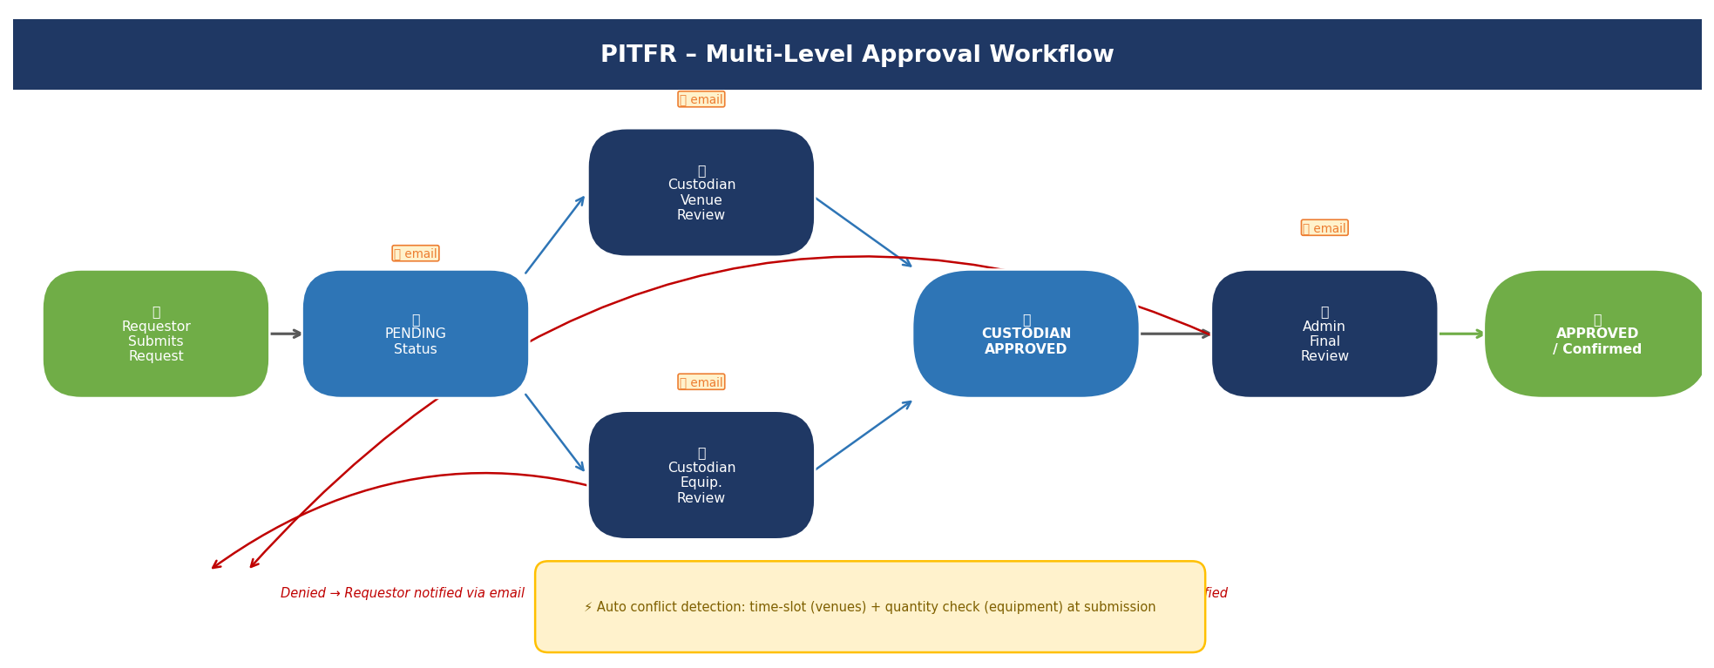
Figure 3. PITFR Multi-Level Approval Workflow (Requestor → Custodian → Admin)

4.1 Expected Load
4.1.1 Estimated number of users
Under normal operational conditions, PITFR is expected to serve 2 to 6 concurrent administrative users (custodians and admin). Requestors (students and faculty) will access the system primarily during business hours on weekdays. During off-peak periods, as few as one administrator may be actively reviewing or approving pending requests.

4.1.2 Peak usage scenario
The most demanding operational scenario occurs at the opening weeks of each academic semester, when student organizations, faculty departments, and institutional offices submit reservation requests for upcoming events. During peak windows, the system may receive 20 to 40 simultaneous reservation submissions within a concentrated period. Each submission triggers multiple database write operations across the facility_requests, facility_request_venues, facility_request_equipment, and notifications tables, as well as potential file attachment uploads and SMTP notification dispatch.
A secondary peak scenario occurs when the Admin generates system-wide PDF and Excel reports at the end of each semester, requiring larger aggregation queries across the full facility_requests dataset joined with pivot tables. The system must sustain acceptable response times (under 3 seconds per transaction) throughout these peak windows without service interruption.

4.2 Scaling Approach
☑ Vertical Scaling (increase resources) ☐ Horizontal Scaling (add servers)

Vertical scaling is the selected approach for PITFR, and it is the most appropriate strategy for this deployment context. The system operates within a single on-premise institutional server serving a geographically confined user base on the PIT campus network. The expected user concurrency ceiling (under 10 simultaneous users) and transaction volume do not justify the complexity and cost of horizontal scaling architectures such as load-balanced server clusters or containerized microservices.
Vertical scaling means that when additional computational resources are required—due to a growing user base, expanded system features such as a public-facing portal, or increased concurrent administrative staff—the institution upgrades the existing server's hardware: increasing RAM, upgrading to a faster CPU, or expanding storage capacity. This approach requires no changes to the Laravel application architecture and aligns with PIT's institutional constraints regarding budget, IT staffing, and infrastructure management.

4.3 Scaling Plan
4.3.1 When scaling is needed
Scaling should be considered when the system exhibits measurable performance degradation against baseline benchmarks established during initial deployment. Specifically, scaling is warranted under any of the following conditions: (1) average page response times consistently exceed 3 seconds during peak reservation submission windows as logged by Laravel Telescope or server-side monitoring; (2) MySQL query execution time for core transactions—facility_request inserts, conflict detection queries, approval status updates—exceeds 500 milliseconds on average; (3) the active user base grows beyond 500 concurrent registered users, significantly increasing database record volume and report generation load; (4) new modules such as a mobile-responsive public portal, integration with the PIT Student Information System, or real-time calendar synchronization are introduced, substantially increasing application complexity and server resource demands.

4.3.2 How scaling will be triggered
Scaling decisions will be triggered through a manual monitoring and review process. The assigned system administrator (IT faculty or student developer) will monitor server performance using lightweight open-source tools, including htop for real-time CPU and memory utilization and MySQL's slow query log for database performance analysis. A performance review will be conducted at the end of each semester's peak reservation period. If logged metrics indicate that the defined performance thresholds have been breached consistently (on more than 20% of transactions during the peak window), the development team will prepare a hardware upgrade recommendation for the PIT administration, specifying the required RAM increase, CPU upgrade, or storage expansion with cost estimates and an implementation timeline during the academic off-season.

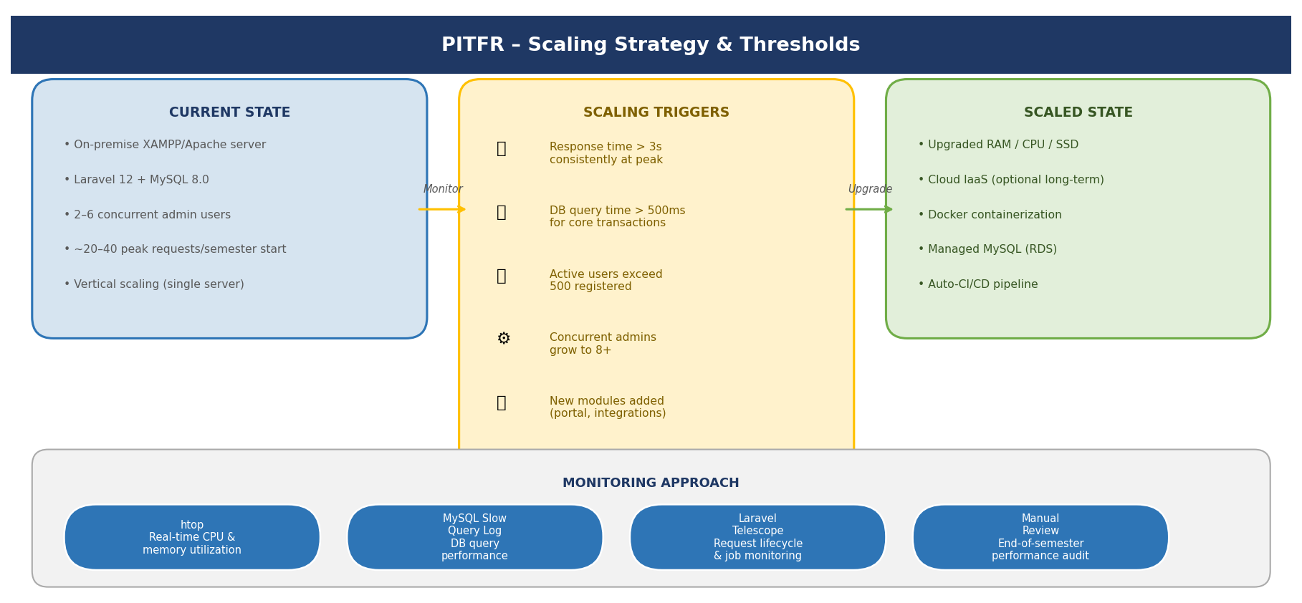
Figure 4. PITFR Scaling Strategy – Current State, Triggers, and Scaled State

5. Availability & Reliability
Ensuring the continuous availability of PITFR during peak reservation periods is critical, as system downtime directly prevents faculty and students from submitting requests and delays custodian and admin approval workflows. The availability strategy is designed around the institution's on-premise deployment constraints, prioritizing preventive maintenance, data redundancy through regular backups, and clearly defined downtime response procedures.

5.1 Availability Strategy
5.1.1 Load balancing (conceptual)
Given that PITFR is deployed on a single on-premise server serving a maximum of approximately 10 concurrent users, traditional load balancing across multiple servers is not operationally necessary at this scale. However, at the application level, a conceptual load management approach is implemented through Apache's built-in MaxRequestWorkers configuration, which limits the number of simultaneous PHP-FPM processes to prevent any single resource-intensive operation—such as a bulk Excel report generation or a large file attachment upload—from consuming all available server memory and degrading response times for concurrent users.

5.1.2 Redundant systems
To protect against data loss and ensure recoverability after hardware or software failures, PITFR implements a two-level data redundancy strategy. At the database level, automated MySQL dump scripts create full database backups stored in a separate directory on the production server and copied to an external storage medium maintained by the designated IT personnel. At the application level, all reservation records, approval histories, audit logs, and uploaded attachments are stored persistently in the MySQL database and the server's file system, respectively, ensuring that no transaction data exists solely in temporary memory.

5.2 Downtime Handling
5.2.1 What happens if the system fails?
In the event of an unexpected system failure during peak reservation periods, the following escalation procedure will be followed. The IT-designated personnel (or student developer assigned to system maintenance) will be immediately notified by administrative staff. A system status check will determine whether the failure originates from the web server process (Apache crash), the database service (MySQL failure), the network infrastructure (LAN switch or router fault), or a power disruption. If the failure cannot be resolved within 30 minutes, reservation requests will temporarily revert to a manual interim process—using paper request forms—to avoid delays in event planning. Once the system is restored, all manually recorded requests from the downtime window will be encoded into PITFR to maintain record integrity and continuity.

5.2.2 Backup Strategies
PITFR implements a structured three-tier backup strategy. First, automated nightly database backups are executed via a MySQL dump cron job at 11:00 PM daily, generating compressed SQL dump files stored in a designated /backups directory on the production server, retained for a rolling 30-day window. Second, weekly manual backups are copied from the production server to a password-protected external storage device maintained by the PIT IT office. This off-server copy protects against catastrophic server hardware failure, including disk corruption or physical damage. Third, prior to any scheduled system update or new feature deployment, a pre-deployment backup is executed to create a restore point, allowing rollback to the last known stable state if the update introduces critical errors.

6. Failure & Risk Analysis
A comprehensive failure and risk analysis was conducted to identify potential failure scenarios that could affect the operation of PITFR during peak reservation periods. Given the system's on-premise campus deployment, risks encompass technical failures, infrastructure limitations, and human operational errors.

6.1 Possible Failures
Failure Scenario | Impact
Apache / Laravel server crash | The PITFR web interface becomes completely inaccessible. All active user sessions are terminated and any unsaved form data is lost. Reservation submissions, approvals, and report generation are halted until the service is restarted.
MySQL database failure | All data operations are halted—reservation reads, approval writes, conflict detection queries, and audit log inserts all fail. The interface may load but returns database connection errors on every action.
School LAN / network outage | All campus workstations and devices lose access to the application server. Even if the server is operational, no users can reach PITFR from the campus network.
Power outage | Abrupt server shutdown may corrupt in-progress database writes or active Laravel sessions, potentially causing partial reservation records and data inconsistency in the facility_requests and pivot tables.
Email notification failure (Mailtrap/SMTP) | Requestors and approvers do not receive email alerts for submission confirmations, approval actions, or denial notices. Reservation workflows can continue, but stakeholders must manually check the system for status updates.
File attachment upload failure | Supporting documents cannot be attached to reservation requests, requiring requestors to submit attachments through alternative channels or resubmit once the issue is resolved.
Session timeout causing unsaved form data loss | If a user's Laravel session expires mid-transaction (e.g., during a lengthy reservation form encoding), all unsaved input is lost, requiring re-entry.
Scheduling conflict detection logic failure | Double-booking of venues or over-allocation of equipment becomes possible, requiring manual review and reconciliation of reservations by custodians and admin.

6.2 Mitigation Strategies
MySQL Database Failure
A cron job monitors the MySQL service status at 5-minute intervals and triggers an automatic restart if the service is found stopped. The Laravel database connection layer is configured with retry logic and a graceful error page that informs users to contact the system administrator. Nightly mysqldump backups ensure the most recent day's data can be restored within 30 minutes of a full database recovery operation.

LAN Network Outage
Network infrastructure failures are addressed through two mitigation measures. First, the institution is advised to maintain one spare network switch for rapid hardware replacement. Second, the system documentation includes an offline contingency procedure: in the event of a total network failure, administrative staff revert to paper-based reservation forms, with all data to be encoded into PITFR once connectivity is restored.

Power Outage
The production server is connected to an Uninterruptible Power Supply (UPS) unit capable of sustaining server operations for a minimum of 15 minutes during a power interruption. This grace period allows the system administrator to execute a controlled server shutdown procedure, saving all in-progress database writes and closing active sessions gracefully. MySQL's InnoDB storage engine provides transaction logging (redo/undo logs) that enables crash recovery after uncontrolled shutdowns.

Email Notification Failure
Laravel's mail dispatch is wrapped in a try-catch exception handler. If SMTP delivery fails, the error is logged to Laravel's application log and a retry is queued via Laravel's job queue. Requestors and approvers can always check the in-system notification panel (notifications table) for the latest status updates, even if email delivery is delayed.

Session Timeout and Data Loss
Laravel's session lifetime is configured to 60 minutes of inactivity—longer than a typical reservation form completion—to reduce the frequency of session timeouts during active use. The reservation encoding form implements client-side auto-save logic using JavaScript's localStorage to periodically save draft form data every 30 seconds. If a session expires, the user is prompted to log in again, after which the system restores the saved draft, preventing complete re-entry.

7. Security Considerations

7.1 Authentication (login system)
PITFR implements a form-based authentication system using Laravel's built-in authentication scaffolding and session management. All users must authenticate with a registered email and password before accessing any system functionality. User credentials are stored in the users table with passwords hashed using Laravel's Hash::make() function, which applies the bcrypt algorithm. Upon successful authentication, a unique Laravel session identifier is generated and stored in a browser cookie with the HttpOnly flag set to prevent JavaScript access. Sessions are invalidated after 60 minutes of inactivity and destroyed upon user logout.

7.2 Data Protection (encryption concept)
Sensitive data transmitted between client browsers and the server is protected using HTTPS (HTTP over TLS/SSL). An SSL certificate installed on the production Apache server encrypts all request and response payloads in transit, protecting student and faculty personal information, reservation records, and authentication credentials from interception on the campus LAN. At the database level, reservation records and user data are stored in plaintext within the MySQL database, as field-level encryption is beyond the current project scope. However, the MySQL server is configured to accept connections only from localhost, preventing direct remote network access to the database. All database credentials are stored in Laravel's .env file, which is excluded from the Git repository via .gitignore.

7.3 Access Control
PITFR implements Role-Based Access Control (RBAC) with five defined roles: Student, Faculty (Requestor), Custodian-Venue, Custodian-Equipment, and Admin. Requestors can submit and track their own reservations. Custodian-Venue officers manage venue availability and first-level approvals for venue requests. Custodian-Equipment officers manage equipment inventory and first-level approvals for equipment requests. The Admin role holds final approval authority and full system access, including user management, master schedule oversight, report generation, and audit log review.
All Laravel routes are protected by authentication middleware. Role-level authorization is enforced via Laravel gates and policies before rendering sensitive interface elements or executing privileged actions. Direct URL manipulation without an authorized session returns a 403 Forbidden or redirect-to-login response.

8. CI/CD Integration

8.1 How CI/CD connects to deployment
The Continuous Integration and Continuous Deployment (CI/CD) pipeline for PITFR is implemented using GitHub as the version control platform, with GitHub Actions as the automated CI workflow engine. The pipeline bridges development and production by automating code quality checks and test execution on every push to the shared repository. This ensures that integration errors, syntax failures, and failed tests are detected immediately in the development phase before code reaches the staging or production environments—directly connecting CI outcomes to deployment readiness decisions.

8.2 When deployment occurs
Deployment to the staging environment occurs when a developer pushes a feature branch and creates a pull request targeting the staging branch. The CI pipeline runs automated checks on the pull request; if all checks pass, the merge is permitted and the staging environment is updated manually by the lead developer for UAT. Deployment to the production environment occurs manually and deliberately: after the project team and subject instructor formally approve UAT results, the staging branch is merged into the protected main branch, and the lead developer performs the production deployment during a scheduled maintenance window via SFTP or SSH, followed by php artisan migrate --force to apply schema changes.

8.3 What is automated
The following CI tasks are automated through the GitHub Actions workflow configuration (.github/workflows/ci.yml):
- PHP Syntax Validation: On every push, PHP's built-in linter (php -l) is executed against all PHP source files to detect syntax errors.
- PHPUnit / Laravel Feature Tests: Automated tests covering core business logic—conflict detection, approval workflow state transitions, role-based access enforcement, and notification dispatch—are executed in the CI environment.
- Laravel Pint (Code Style): Laravel's code style enforcer runs to ensure consistent formatting across all team members' contributions.
- Database Migration Dry-Run: Laravel migration scripts are validated against a CI test database instance to confirm schema changes are syntactically correct before application to staging or production.
- Build Artifact Packaging: Upon a successful merge to the main branch, GitHub Actions packages the application files for manual transfer to the production server via SFTP.

9. Tools & Technologies
Name | Purpose
Laravel 12 (PHP Framework) | The core application framework. Provides MVC architecture, Eloquent ORM, authentication scaffolding, job queues, event-listener system, and Artisan CLI for migrations and seeding.
MySQL 8.0 (Database) | Relational database storing all system data across nine normalized tables. Enforces foreign key constraints and supports complex joins for conflict detection and report aggregation queries.
PHP 8.2 (Runtime) | Server-side scripting runtime for all Laravel application logic, including reservation workflow processing, audit logging, SMTP notification dispatch, and PDF/Excel report generation.
Apache HTTP Server (Hosting) | Serves the PITFR web application over HTTP/HTTPS. Manages PHP-FPM request routing and enforces access restrictions via .htaccess configuration.
Tailwind CSS v3 + Vite (Frontend) | Tailwind provides utility-first CSS styling for all UI components. Vite bundles and hot-reloads assets during development, producing optimized production builds.
Mailtrap SMTP (Email) | Provides a sandboxed SMTP service for sending email notifications to requestors and approvers at each step of the reservation approval workflow.
XAMPP (Dev Environment) | Local development stack (Apache + MySQL + PHP) running on Windows. Project located at C:\xampp\htdocs\pitfr with database pitfr.
GitHub Actions (CI/CD) | Automated workflow engine executing PHP linting, PHPUnit feature tests, Laravel Pint style checks, and migration validation on every push or pull request to the shared repository.
Laravel Telescope (Monitoring) | Developer-facing debugging and monitoring dashboard providing request lifecycle inspection, database query logs, and job/event monitoring for performance analysis.

10. Reflection

10.1 What challenges did you encounter in designing deployment?
One of the most significant challenges was reconciling Laravel 12's modern deployment conventions—environment variable management, queue workers, scheduled task runners, compiled asset pipelines—with the resource and infrastructure constraints of an on-premise school server running XAMPP. Enterprise deployment guides for Laravel typically assume cloud infrastructure (AWS, DigitalOcean, Forge) or containerized environments (Docker, Kubernetes) that are not practically available within PIT's operational context. This required the team to thoughtfully adapt deployment best practices into simpler but equivalent solutions, such as using Windows Task Scheduler as a substitute for a Linux cron job to run Laravel's scheduler (php artisan schedule:run), and configuring Mailtrap's sandbox SMTP in lieu of a production mail server.
A second challenge was designing the nine-table normalized schema—particularly the pivot tables (facility_request_venues and facility_request_equipment)—to support robust conflict detection queries without degrading performance. Replacing the original JSON array approach with proper relational pivot tables increased query complexity but significantly improved data integrity and indexability.

10.2 What assumptions did you make?
The deployment plan was developed on several foundational assumptions about the operational context of Palompon Institute of Technology. First, it is assumed that the institution has or will acquire a dedicated on-premise server with minimum specifications of 8 GB RAM, a quad-core 64-bit processor, 500 GB HDD, and a stable campus LAN connecting user workstations. Second, it is assumed that a designated IT faculty member or student developer will be available to perform scheduled maintenance tasks, execute backup transfers, run Laravel's scheduler, and respond to service disruption alerts. Third, it is assumed that the campus LAN provides reliable internal connectivity during peak reservation periods, as PITFR is designed for campus-network access rather than public internet deployment at this stage.
Fourth, it is assumed that all five user roles will receive an orientation session on system login procedures, reservation submission workflows, and error reporting protocols prior to the system going live, reducing the probability of operator-induced errors. Fifth, the choice of a XAMPP-based local development environment assumes that all team members are running Windows and have consistent XAMPP configurations, which was addressed through a shared .env.example file and documented setup instructions in the project README.

10.3 What would you improve in a real-world system?
In a real-world production deployment beyond the capstone scope, the most impactful improvement would be migrating PITFR from on-premise XAMPP hosting to a cloud-based platform such as a local Philippine cloud provider or AWS. Cloud hosting would provide automated managed database backups, elastic vertical scaling without hardware procurement lead times, trusted SSL certificates from a certificate authority, and a managed Laravel Forge or Envoyer deployment pipeline—eliminating the manual SFTP deployment process.
A second critical improvement would be containerizing the application using Docker, packaging the Laravel app, Apache, and MySQL into Docker containers with a docker-compose.yml configuration. This would eliminate environment discrepancies between development and production instances, simplify onboarding of new developers, and provide a reproducible deployment unit that can be migrated between servers quickly.
Third, the system would benefit substantially from a real-time calendar integration using a library such as FullCalendar.js directly connected to the conflict detection engine, providing administrators and requestors with a visual overview of all confirmed and pending reservations before submission—reducing user error and improving the experience of the scheduling workflow.

11. Appendix

11.1 Additional Diagrams
Entity-Relationship Diagram (ERD) of the MySQL Database Schema. The PITFR ERD comprises nine tables: users (id, name, email, password, role ENUM[student, faculty, custodian-venue, custodian-equipment, admin]); venues (id, name, capacity, description, status); equipment (id, name, total_quantity, available_quantity, description); facility_requests (id, requestor_id FK→users, event_name, event_date, start_time, end_time, is_priority ENUM[low,medium,high], status, custodian_venue_approved_by FK→users, custodian_equipment_approved_by FK→users, admin_approved_by FK→users, notes); facility_request_venues (id, facility_request_id FK, venue_id FK); facility_request_equipment (id, facility_request_id FK, equipment_id FK, quantity_requested); request_attachments (id, facility_request_id FK, file_path, original_filename); audit_logs (id, user_id FK, action, target_type, target_id, description, created_at); notifications (id, user_id FK, facility_request_id FK, message, is_read, created_at).

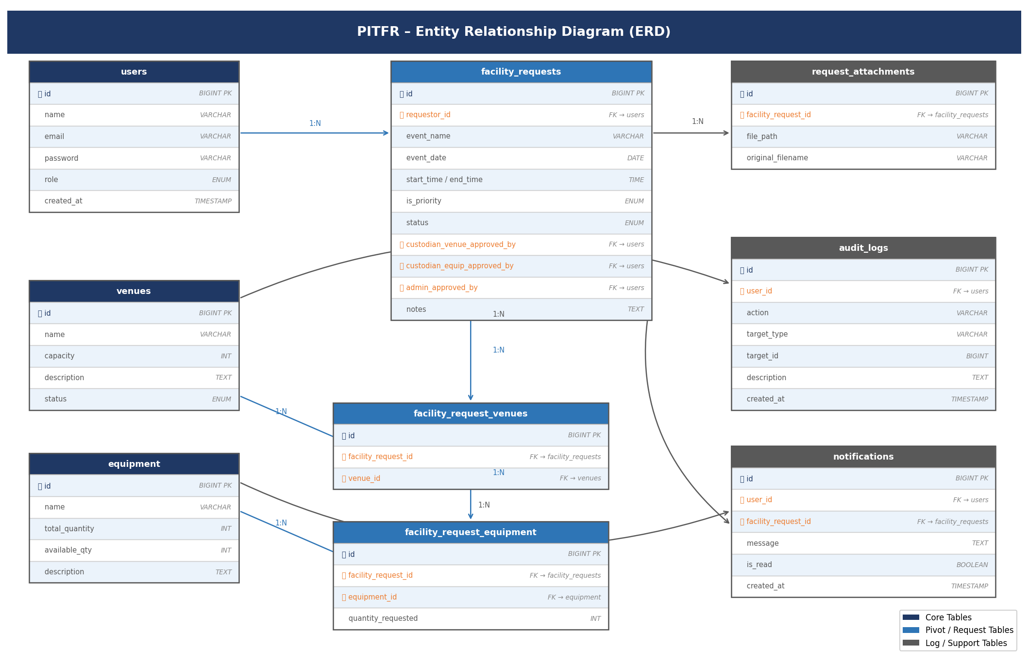
Figure 5. PITFR Entity Relationship Diagram (ERD) – Nine-Table Normalized Schema

11.2 Screenshots
Insert system screenshots here. Add a brief caption and description after each screenshot explaining the feature shown.

11.3 Notes (optional)
- All development is performed on Windows 10/11 with XAMPP. The project root is C:\xampp\htdocs\pitfr and the database name is pitfr.
- Laravel 12 is used with PHP 8.2. The .env file is excluded from version control via .gitignore; use .env.example as the configuration reference.
- Tailwind CSS v3 is compiled via Vite. Run npm run dev for development and npm run build for production asset bundling.
- Mailtrap SMTP credentials are configured in the .env file under the MAIL_* environment variables. The sandbox inbox is used for all development and staging email testing.
- Database migrations are managed via Laravel Artisan. Run php artisan migrate to apply all pending migrations and php artisan db:seed to populate reference data (venues, equipment).

